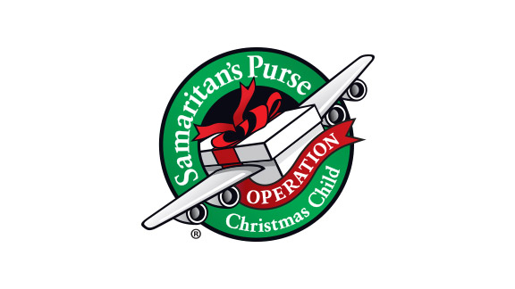
Operation Christmas Child Stores
www.raymondgeddes.com/
  - School supplies
  - Small toys
www.orientaltrading.com
  - Small toys in bulk (check the end of summer sale items)
www.dollartree.com (ship to store for free shipping – just add Megan as the person who will pick up the order)
  - School supplies
  - Plastic water bottles
  - Reusable utensils
  - Small toys/books/puzzles
  - Brushes/Combs/Hair bands
  - Washcloths
  - Flashlights
  - Batteries
www.mdsupplies.com/shoebox (free shipping to all OCC shoppers)
  - Combs, toothbrushes, toothbrush holders, Band-Aids, etc.
https://www.amazon.com/hz/wishlist/ls/NM5FPOLJER2A?ref_=wl_share (Amazon Wishlist)
  - Small toys
  - Socks
www.target.com
  - School supplies
  - Small toys/puzzles
  - Socks/underwear/t-shirts (all sizes)
www.childrenplace.com
  - Clearance clothing (sizes 4+)
  - Clearance flipflops
  - Clearance accessories

