23rd Sunday After Pentecost
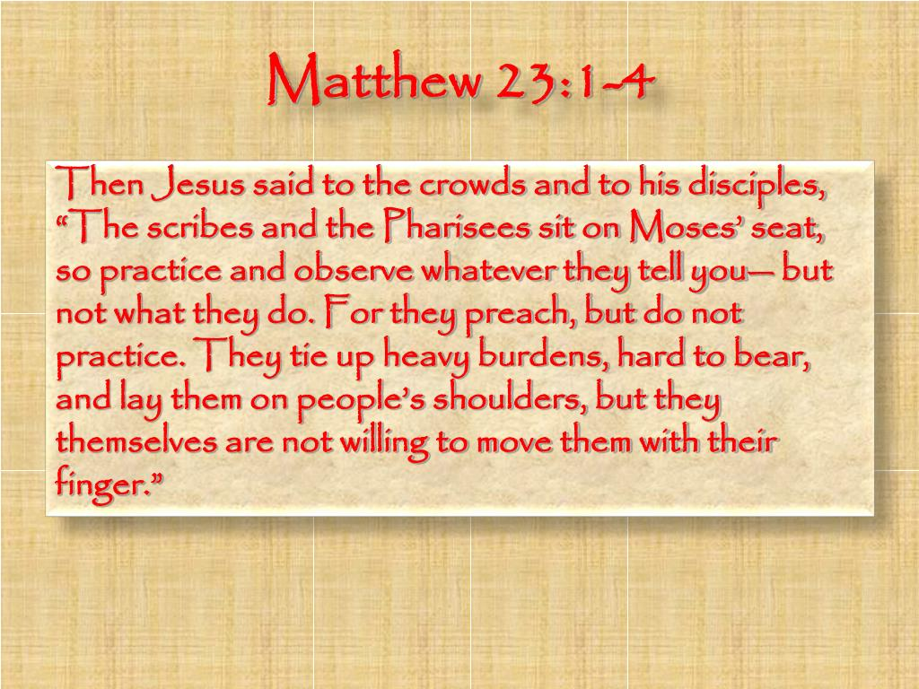

10 A. M. Worship for Sunday, November 5, 2023
First Memorial Presbyterian Church of Dover, New Jersey

Gathering and Focusing during Prelude: - Rachel Persenaire
Thank you for choosing to worship our Lord and Savior Jesus Christ with us today!
*We invite you to stand if you are able for those portions of the liturgy marked with an asterisk.

xx
Sung Approach to Worshiping Our God: - Rachel Persenaire

All: CHORUS: He who began a good work in you,
He who began a good work in you will be faithful to complete it
He’ll be faithful to complete it,
He who started the work will be faithful to complete it in you.

VERSE: If the struggle you’re facing
is slowly replacing your hope with despair,
Or the process is long, and you’re losing your song in the night.
You can be sure that the Lord has his hand on you,
safe and secure, He will never abandon you,
you are his treasure, and he finds his pleasure in you.
(repeat chorus)

- Words and Music by John Mohr, © 1987, 1995; by Johnathan Mark Music/ASCAP.
(administered by Gaither Copyright management) All rights reserved.
Permission for use granted by Christian Copyright Licensing Inc., license #970294
Found in RENEW! SONGS & HYMNS for BLENDED WORSHP, Hymn No. 134.

Opening Words:
Rachel: O give thanks to the Lord, who is good.

God’s steadfast love endures forever!

Let the redeemed of the Lord say so:

All: God’s steadfast love endures forever! - Psalm 107:1 & 2
(Let us worship God.)

- The Opening Words (above) are as found on pages 224. of Feasting On the Word, Liturgies for Year A, vol.2.
© 2013, by WESTMINSTER JOHN KNOX PRESS, Louisville, KY. All rights reserved. Used with the permission.

Call to Confession:
Alan: God is the one in whom we are called to take refuge,
who eternally forgives and renews.

Therefore, let us name before God and each other
how we have turned away from the source of truth
so that in our humility, we may be truly exalted.

(Let us pray with one voice
and receive this amazing grace from God.)

Corporate Prayer of Confession:
Alan: We acknowledge before you, O God,
that we are drawn to false teachings,

We succumb to the adoration of this world
when we seek to be noticed, crave being honored,
and look for the best seats.

We have ignored the true teacher
who calls us to live a life of humility, kindness,
and service toward others,

Forgive us. Help us to practice the teachings of Jesus.

As we long to place our burdens on you,
confident that you will lighten our journeys,
so we long to ease the burdens of our friends, families, neighbors,
and creatures of earth.

Set us on your path, O God; in Jesus’ name

All: Amen…

(We pause here for a few moments of silent, personal confession…)

Assurance of Pardon:
Alan: God is filled with everlasting mercy and desire for your well-being.

God’s beloved Jesus was given to dwell among us
and, in dying, was raised to be with us always.

In the gift of resurrection,
we can rejoice and know the hope of renewed lives.

Trust that you are forgiven, that you belong to the Creator,
Redeemer, and Sustainer who has known you for ages.

All: Thanks be to God! (Amen.)

- The Prayer of Confession and Assurance of Pardon (above) are as found on pages 228 & 229.
of Feasting On the Word, Liturgies for Year A, vol.2.
© 2013, by WESTMINSTER JOHN KNOX PRESS, Louisville, KY. All rights reserved. Used with the permission.

*Hymn of Praise No. 275: – Hugh Thomson Kerr, 1916
“God of Our Life”

*Celebrating the Peace Jesus Came to Bring:
- Rev. Alan R. Schaefer
Alan: Christians in the United States are belittled for our faith
by people as close as next door.

All: Christians around the world are imprisoned, or killed,
by people of other faiths, and by people with no faith.

Alan: Yet God calls us from east and west, and from north and south,
to sit at his table in ‘the Kingdom of Heaven.’

All: God calls us here and now to share in the feast of love
which offers us peace with God and with each other.

Alan: Without moving from where you now stand,
please take the next few moments to share a warm greeting
and a sincere sign of God’s peace with those around you.

Choral Anthem: “Nearer, My God to Thee”

Children’s Message: - Megan Quinones

Sung Prayer for Illumination: - Philip P. Bliss
- Sing them over again to me, Wonderful words of Life;
Let me more of their beauty see,
Wonderful words of Life.
Words of life and beauty, Teach me faith and duty…

Refrain: Beautiful words, wonderful words,
Wonderful words of Life. (repeat)

- Christ, the blessed One, gives to all, Wonderful words of Life;
Sinner, listen to the loving call,
Wonderful words of life.
All so freely given, Wooing us to heaven—
(Refrain w/repeat)

- Sweetly echo the gospel call, Wonderful words of Life;
Offer pardon and peace to all,
Wonderful words of Life.
Jesus, only Savior, Sanctify forever.
(Refrain w/repeat)
- Words & Music by Philip P. Bliss—Now in the public domain. Hymn No 406 in THE CELEBRATION HYMNAL

Scripture Lesson: - Megan Quinones
The Gospel According to Matthew
chapter 23: verses 1 thru 12
Hear what the Spirit is saying to the Church… - Revelation 2:7

¹ Then Jesus said to the crowds and to his disciples,
² “The scribes and the Pharisees sit on Moses’ seat;
³ therefore, do whatever they teach you and follow it;
but do not do as they do, for they do not practice what they teach.

⁴ They tie up heavy burdens, hard to bear,
and lay them on the shoulders of others,
but they themselves are unwilling to lift a finger to move them.

⁵ They do all their deeds to be seen by others,
for they make their phylacteries broad and their fringes long.

⁶ They love to have the place of honor at banquets
and the best seats in the synagogues.

⁷ and to be greeted with respect in the marketplaces,
and to have people call them rabbi.

⁸ But you are not to be called rabbi,
for you have one teacher, and you are all students.

⁹ And call no one your father on earth, for you have one Father
—the one in heaven.

¹⁰ Nor are you to be called instructors,
for you have one instructor, the Messiah.

¹¹ The greatest among you will be your servant.

¹² All who exalt themselves will be humbled,
and all who humble themselves will be exalted.”

- THE NEW REVISED STANDARD VERSION (of the Bible-a translation)
© 1989 by the Division of Christian Education of the National Council of the Churches of Christ in the U. S. A. All rights reserved.

Megan: This is the Word of the Lord…
All: Thanks be to God!

Adult Message: - Rev. Alan R. Schaefer
“Be Careful Who You Follow”
Text: Matthew 23: 2 & 3 — “The Scribes and the Pharisees sit on
Moses’ seat; therefore, do whatever they teach you and follow it;
but do not do as they do, for they do not practice what they teach.

Call for the Offering and Prayer of Dedication:
Alan: We are grateful to have you with us as we worship together
on this twenty-third Sunday after Pentecost,
and we hope you can be stewardship partners with us
in our ministry as you have been partners with us in our worship,
whether here, in our sanctuary,
or somewhere safe or convenient to you on your computer.

If you worshiped with us on your computer, and are able
and willing, please consider mailing an offering to our church
office this week @ 51 West Blackwell Street, Dover NJ 07801.

We give our offerings not to please God,
but to live in thanksgiving for all God’s gifts.

Know that what you give is a response
to the word of hope that lives in you.

Let us pray…

Holy God, through these gifts you nourish us.

You create and sustain our bodies and minds
and all the creatures and elements of earth
that enable us to move and grow.

With these gifts we turn our lives toward the needs of your people
and all in want.

Bless what we offer in Jesus’ name.

All: Amen.

- The Invitation to the Offering & Prayer of Dedication (as above) are as found on page 231.
of Feasting On the Word, Liturgies for Year A, vol.2.
© 2013, by WESTMINSTER JOHN KNOX PRESS, Louisville, KY. All rights reserved. Used with the permission.

Offertory: - Rachel Persenaire
“Our God in Ages Past”

Sacrament of the Lord’s Supper:

Invitation: (open to all who believe)

Consecration:
Consummation:

Appreciation:
Joys and Concerns:

Prayers of and for the People and Lord’s Prayer:
All: …Our Father who art in heaven, hallowed be Thy name…

*Hymn of Parting (on last page): - Helen H. Lemmel, 1922
“Turn Your Eyes Upon Jesus”

*Charge and Benediction:
Alan: People of God, servants of our eternal teacher,
(I charge you to) listen to the Word of God, practice humility,
give thanks for the work you have (been called) to do,
offer your voice on behalf of those whose needs you know.

Walk in peace with your neighbors.

(And) may the One who sends true prophets into our world
guide and keep you in the way of the Lord, this day and always.

Amen?

All: Amen.

- The Charge & Benediction (above) are as found on pages 231 & 232.
of Feasting On the Word, Liturgies for Year A, vol.2.
© 2013, by WESTMINSTER JOHN KNOX PRESS, Louisville, KY. All rights reserved. Used with the permission.

Postlude - Rachel Persenaire

_______________________________________________________________________________________________________________________________________
Unless otherwise noted, most of the bulletin / liturgy is written by the Pastor, the Rev. Mr. Alan R. Schaefer, H. R.

OUR NEXT LORD’S DAY CELEBRATION OF THE SACRAMENT OF HOLY COMMUNION WILL BE ON DECEMBER 3, 2023,
IN THE SANCTUARY.

FIRST MEMORIAL PRESBYTERIAN CHURCH AND CONGREGATION
51 West Blackwell Street, Dover, NJ 07801

A member congregation of Presbytery of the Highlands of New Jersey,
The Synod of the Northeast, and
The General Assembly of the Presbyterian Church, U. S. A.

SOMETHING SPECIAL NEXT WEEK
A LITURGY OF REMEMBRANCE
While All Saints’ Day was November 1st, this year (for time management purposes) we will be celebrating it next Sunday, November 12th. For all wanting to participate there will be an invitation to come forward to place a lighted electric candle on a special board on our Communion Table in remembrance of a person or persons who have gone home to be with the Lord and who have touched their life in a profound way by being a light of God’s love to them.
