Christ the King Sunday
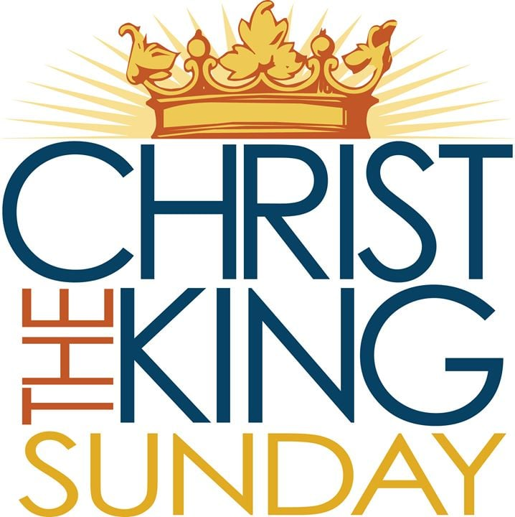

10 A. M. Worship for Sunday, November 26, 2023
First Memorial Presbyterian Church of Dover, New Jersey

Gathering and Focusing during Prelude: - Rachel Persenaire
Thank you for choosing to worship our Lord and Savior Jesus Christ with us today!
*We invite you to stand if you are able for those portions of the liturgy marked with an asterisk.

xx
Sung Approach to Worshiping Our God: - Rachel Persenaire
All: CHORUS: He who began a good work in you,
He who began a good work in you will be faithful to complete it
He’ll be faithful to complete it,
He who started the work will be faithful to complete it in you.

VERSE: If the struggle you’re facing
is slowly replacing your hope with despair,
Or the process is long, and you’re losing your song in the night.
You can be sure that the Lord has his hand on you,
safe and secure, He will never abandon you,
you are his treasure, and he finds his pleasure in you.
(repeat chorus)

- Words and Music by John Mohr, © 1987, 1995; by Johnathan Mark Music/ASCAP.
(administered by Gaither Copyright management) All rights reserved.
Permission for use granted by Christian Copyright Licensing Inc., license #970294
Found in RENEW! SONGS & HYMNS for BLENDED WORSHP, Hymn No. 134.

Opening Words: - Rachel Persenaire
Rachel: O come, let us sing to the Lord;
let us make a joyful noise to the rock of our salvation! Psalm 95: 1, 3

All: For the Lord is a great God;
a great ruler over heaven and earth!

- The Opening Words (above) are as found on pages 261. of Feasting On the Word, Liturgies for Year A, vol.2.
© 2013, by WESTMINSTER JOHN KNOX PRESS, Louisville, KY. All rights reserved. Used with the permission.

Call to Confession:
Alan: (Good morning Saints,) With sincere and repentant hearts, let us name our sins against Christ and one another.

Corporate Prayer of Confession:
Alan: (Join your hearts with mine as I pray…)
Lord Jesus, Judge of the nations: we confess that
we have not seen your face among our neighbors in need.

We have not shared our food with the hungry;
we have not offered clothes to the destitute
or shelter to the homeless.

We have not welcomed the stranger,
nor have we visited prisoners.

We have not paid attention to these, your sisters and brothers,
and in our neglect, we have failed to serve you.

Lord, forgive us; open our eyes to recognize your beloved family,
and give us the blessing of sincere repentance
that we may know the joy of eternal life with you and all the saints
in this world and in the world to come.
All: Amen…

(We pause here for a few moments of silent, personal confession…)

Assurance of Pardon:
Alan: Brothers and sisters, God seeks the lost sheep
and feeds them with justice.

Forgiven and freed, turn, then, and live in Christ our Lord.
All: (Thanks be to God! Amen.)

- The Call to Confession, Prayer of Confession and Assurance of Pardon (above) are as found on pages 261 & 262.
of Feasting On the Word, Liturgies for Year A, vol.2.
© 2013, by WESTMINSTER JOHN KNOX PRESS, Louisville, KY. All rights reserved. Used with the permission.

*Hymn of Praise No. 150: – Christian Henry Bateman, 1843
“Come, Christians, Join to Sing”

*A Historic Confession of Faith:
All: I BELIEVE IN GOD, the Father almighty,
creator of heaven and earth.

I BELIEVE IN JESUS CHRIST, God’s only Son, our Lord,
who was conceived by the Holy Spirit, born of the Virgin Mary,
suffered under Pontius Pilate, was crucified, died,
and was buried; he descended to the dead.

On the third day he rose again;
He ascended into heaven,
he is seated at the right hand of the Father,
and he will come to judge the living and the dead.

I BELIEVE IN THE HOLY SPIRIT, the holy catholic Church,
The communion of saints, the forgiveness of sins,
The resurrection of the body, and the life everlasting. Amen.

- THE APOSTLES’ CREED (Ecumenical Translation)

*Celebrating the Peace Jesus Came to Bring:
- Rev. Alan R. Schaefer
Alan: Christians in the United States are belittled for our faith
by people as close as next door.

All: Christians around the world are imprisoned, or killed,
by people of other faiths, and by people with no faith.

Alan: Yet God calls us from east and west, and from north and south,
to sit at his table in ‘the Kingdom of Heaven.’

All: God calls us here and now to share in the feast of love
which offers us peace with God and with each other.

Alan: Without moving from where you now stand,
please take the next few moments to share a warm greeting
and a sincere sign of God’s peace with those around you.

Choral Anthem: “God, Whose Giving Knows No Ending” - Edwards/Wood

Children’s Message: - Megan Quinones

Sung Prayer for Illumination: - Philip P. Bliss
- Sing them over again to me, Wonderful words of Life;
Let me more of their beauty see,
Wonderful words of Live.
Words of life and beauty, Teach me faith and duty…

Refrain: Beautiful words, wonderful words,
Wonderful words of Life. (repeat)

- Christ, the blessed One, gives to all, Wonderful words of Life;
Sinner, listen to the loving call,
Wonderful words of life.
All so freely given, Wooing us to heaven—
(Refrain w/repeat)

- Sweetly echo the gospel call, Wonderful words of Life;
Offer pardon and peace to all,
Wonderful words of Life.
Jesus, only Savior, Sanctify forever.
(Refrain w/repeat)
- Words & Music by Philip P. Bliss—Now in the public domain. Hymn No 406 in THE CELEBRATION HYMNAL

Scripture Lesson: - Megan Quinones
The Gospel According to Matthew
Chapter 25: verses 31 thru 46
Hear what the Spirit is saying to the Church… - Revelation 2:7

³¹ When the Son of Man comes in his glory, and all the angels with him,
then he will sit on the throne of his glory.

³² All the nations will be gathered before him,
and he will separate people one from another
as a shepherd separates the sheep from the goats,
³³ and he will put the sheep at his right hand and the goats at the left.

³⁴ Then the king will say to those at his right hand, ‘Come,
you that are blessed by my Father,
inherit the kingdom prepared for you
from the foundation of the world;
³⁵ for I was hungry and you gave me food,
I was thirsty and you gave me something to drink,
I was a stranger and you welcomed me,
³⁶ I was naked and you gave me clothing,
I was sick and you took care of me,
I was in prison, and you visited me.’

³⁷ Then the righteous will answer him, ‘Lord,
when was it that we saw you hungry and gave you food,
or thirsty and gave you something to drink?

³⁸ And when was it that we saw you a stranger and welcomed you,
or naked and gave you clothing?

³⁹ And when was it that we saw you sick or in prison and visited you?’

⁴⁰ And the king will answer them, ‘Truly I tell you,
just as you did it to one of the least of these
who are members of my family, you did it to me.’

⁴¹ Then he will say to those at his left hand, ‘You that are accursed
depart from me into the eternal fire prepared for the devil
and his angels;
⁴² for I was hungry and you gave me no food,
I was thirsty and you gave me nothing to drink,
⁴³ I was a stranger and you did not welcome me, naked and you did not
give me clothing, sick and in prison and you did not visit me.

⁴⁴ Then they also will answer, ‘Lord, when was it that
we saw you hungry or thirsty or a stranger or naked or sick
or in prison and did not take care of you?’

⁴⁵ Then he will answer them, ‘Truly I tell you,
just as you did not do it to one of the least of these,
you did not do it to me.’

⁴⁶ And these will go away into eternal punishment,
but the righteous into eternal life.’

- THE NEW REVISED STANDARD VERSION (of the Bible-a translation)
© 1989 by the Division of Christian Education of the National Council of the Churches of Christ in the U. S. A. All rights reserved.

Megan: This is the Word of the Lord…
All: Thanks be to God!

Adult Message: - Rev. Alan R. Schaefer
“No Exceptions, No Excuses!”
TEXT: Matthew 25: 45 — Then he will answer them,
‘Truly I tell you, just as you did not do it to one of the least of these,
you did not do it to me.’

Call for the Offering and Prayer of Dedication:
Alan: We are grateful to have you with us as we worship together
on this year’s Christ the King Sunday;
and we hope you will be stewardship partners with us
in our ministry here and around the world
as you have been partners with us in our worship,
whether here, in our sanctuary,
or somewhere safe or convenient to you on your computer.

If you worshiped with us on your computer, and are able
and willing, please consider mailing an offering to our church
office this week @ 51 West Blackwell Street, Dover NJ 07801.

Invitation to the offering:

God holds the depths of the earth
and the heights of the mountains, the sea and the dry land.

Let us offer our gifts to God, our Maker.

Let us pray…

All: Almighty God, we give you thanks and praise
for your love in Jesus Christ our Lord.

(Please) accept our offering in union with Christ’s offering for us.

Confirm in us
the riches of his glorious inheritance among the saints,
that we may testify to the sovereignty of his love.

Through Christ, with the Holy Spirit, all glory and honor are yours,
Almighty God, now and forever.

Amen.

- The Invitation to the Offering & Prayer of Dedication (as above) are as found on page 264
of Feasting On the Word, Liturgies for Year A, vol.2.
© 2013, by WESTMINSTER JOHN KNOX PRESS, Louisville, KY. All rights reserved. Used with the permission.

Offertory: “How Can I Keep from Singing” - Tomlin

Joys and Concerns:

Prayers of and for the People and Lord’s Prayer:
Alan: …Amen.
All: Our Father who art in heaven, hallowed be Thy name…

*Hymn of Parting No. 151: – Matthew Bridges, 1851
“Crown Him with Many Crowns”

*Charge and Benediction:
Alan: (I charge you…) to encourage one another
and build each other up,
faithfully working together for the kingdom of God,
as we await the day of Christ’s coming.

(And) May the God of creation
work wonders in you by the power of the Holy Spirit,
until we enter together the joy of our Master.

Amen?

All: Amen.

- The Charge & Benediction (above) are as found on pages 25 of Feasting On the Word, Liturgies for Year A, vol.2.
© 2013, by WESTMINSTER JOHN KNOX PRESS, Louisville, KY. All rights reserved. Used with the permission.

Postlude: - Rachel Persenaire

_______________________________________________________________________________________________________________________________________

Unless otherwise noted, most of the bulletin / liturgy is written by the Pastor, the Rev. Mr. Alan R. Schaefer, H. R.

OUR NEXT LORD’S DAY CELEBRATION OF THE SACRAMENT OF HOLY COMMUNION WILL BE ON DECEMBER 3, 2023,
THE FIRST SUNDAY OF ADVENT, IN THE SANCTUARY.

FIRST MEMORIAL PRESBYTERIAN CHURCH AND CONGREGATION
51 West Blackwell Street, Dover, NJ 07801

A member congregation of Presbytery of the Highlands of New Jersey,
The Synod of the Northeast, and
The General Assembly of the Presbyterian Church, U. S. A.

