First Sunday of Christmas
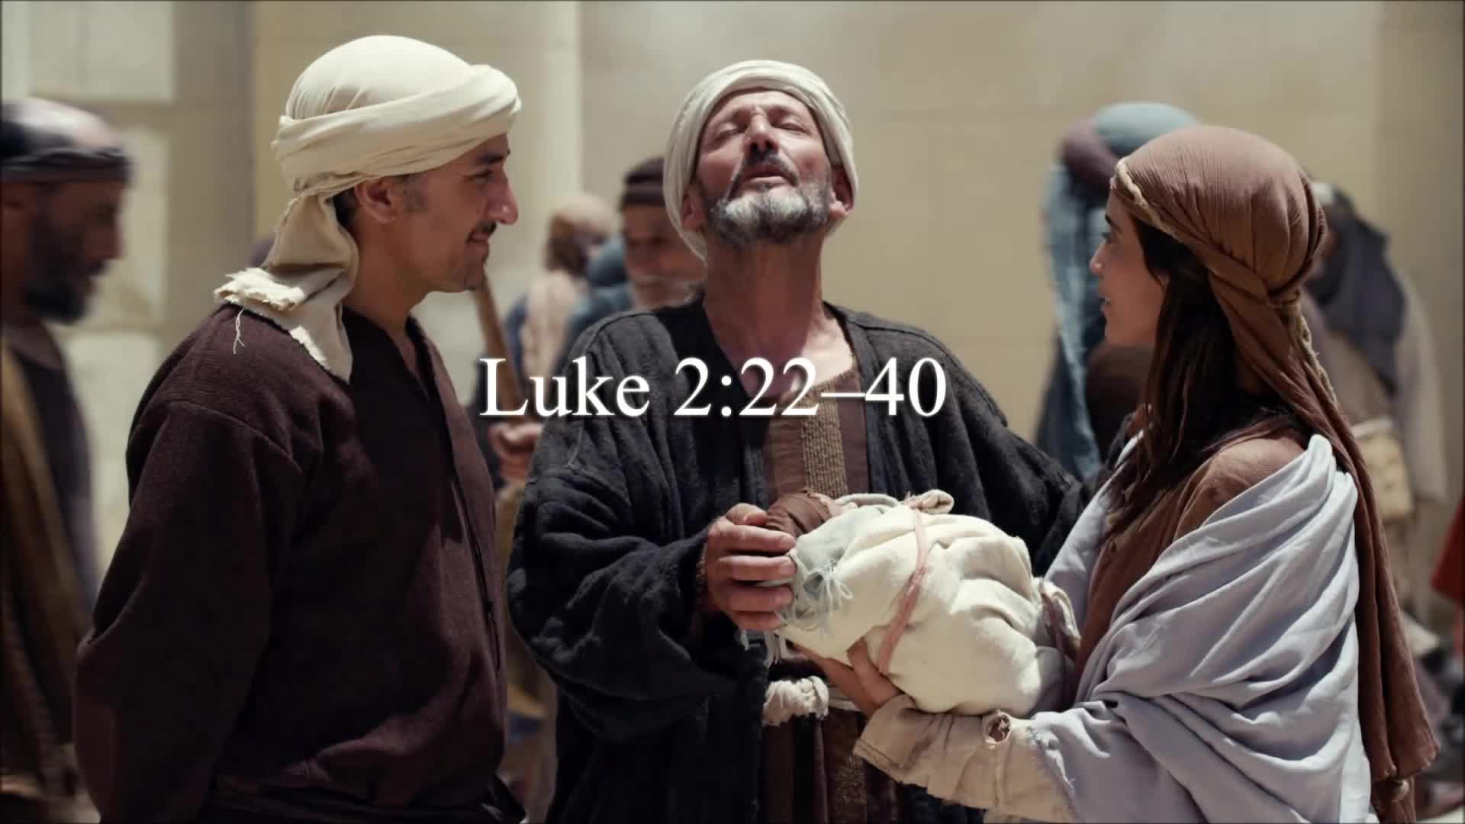

10 A. M. Worship for Sunday, December 31, 2023
First Memorial Presbyterian Church of Dover, New Jersey

Gathering and Focusing during Prelude: - Rachel Persenaire
Thank you for choosing to worship our Lord and Savior Jesus Christ with us today!
*We invite you to stand if you are able for those portions of the liturgy marked with an asterisk.

xx
Sung Approach to Worshiping Our God: - Rachel Persenaire
*Hymn No. 40: - Isaac Watts, 1719
“Joy to the World”

Opening Words: - Rachel Persenaire
Rachel: Praise the Lord! Praise God from the heavens.

Young men and women alike, old and young together!
- Psalm 148: 1, 12
All: Let us praise the name of the Lord,
Whose name alone is exalted above earth and heaven.
- Psalm 148:13
- The Opening Words (above) are as found on page 30. of Feasting On the Word, Liturgies for Year B, vol.1.
© 2014, by WESTMINSTER JOHN KNOX PRESS, Louisville, KY. All rights reserved. Used with the permission.

Call to Confession:
Alan: (Good morning Saints,) Jesus our Lord
came into an indifferent world,
yet his life revealed the inner thoughts of many.

Let us confess our sins before God and one another
that we may receive release from our sin…

Corporate Prayer of Confession:
Alan: (Let us pray…)
All: Merciful God,
we confess that we have not lived as your faithful children.

We have kept silent in the midst of prejudice and hatred.

We have been idle in the face of violence and injustice.

We have not been a light to the nations,
and our lives have not revealed your glory.

Forgive us, Merciful God.

Repair the ugliness of our sin
and restore in us your beautiful grace;
through Jesus Christ our Lord. Amen.

(We pause here for a few moments of silent, personal confession…)

Assurance of Pardon:
Alan: Beloved of God, as a bridegroom decks himself with a garland,
as a bride adorns herself with her jewels,
God covers us with the love of righteousness.

Know that you are forgiven in Jesus Christ
and live as God’s beloved.

All: (Thanks be to God! Amen.)

- The Call to Confession, Prayer of Confession and Assurance of Pardon (above) are as found on pages 30 & 31.
of Feasting On the Word, Liturgies for Year B, vol.1.
© 2014, by WESTMINSTER JOHN KNOX PRESS, Louisville, KY. All rights reserved. Used with the permission.

*Hymn of Praise No. 22: – James Montgomery, 1816, 1825
“Angels from the Realms of Glory”

*A Historic Confession of Faith from the PCUSA BOOK OF
CONFESSIONS: THE SCOTS CONFESSION, chapter 6:
All: When the fullness of time came God sent his Son,
His eternal wisdom, the substance of his own glory,
into this world,
who took the nature of humanity
from the substance of a woman, a virgin,
by means of the Holy (Spirit),

And so was born the “just seed of David,”
The “Angel of the great counsel of God,”
the very Messiah promised,
whom we confess and acknowledge to be Emmanuel,
true God and true (human),
two perfect natures united and joined in one person… (Amen!)

– Volume One of the Constitution of the Presbyterian Church in the United Stated of America

*Celebrating the Peace Jesus Came to Bring:
- Rev. Alan R. Schaefer
Alan: We’ve got “good news” to tell…

All: We have found a babe wrapped in swaddling cloths.

Alan: He was laid in a manger…

All: Because there was no room for him in the inn,
nor in the hearts of many.

Alan: Let US make room for him in OUR hearts,
like he has done for you and for me,
and reach out to all God’s children with his love.

All: To do so we must share the peace of Christ with one and all!

Alan: Without moving from where you now stand,
please take the next few moments to share a warm greeting
and a sincere sign of God’s peace with those around you.

Choral Anthem: “Who Would Think That What Was Needed”
- Bell/Maule
Children’s Message: - Megan Quinones

Sung Prayer for Illumination: - Naida Hearn, 1975
Jesus, name above all names beautiful Savior, glorious Lord.
Emmanuel, God is with us blessed Redeemer, Living Word.

- ©1974, 1978 by MARANATHA MUSIC. All rights reserved.
Used with the permission granted under Christian Copyright Licensing Inc. License 970294

Scripture Lesson: - Megan Quinones
The Gospel According to Luke
chapter 2: verses 22 thru 40
Hear what the Spirit is saying to the Church… - Revelation 2:7

²² When the time came for their purification
according to the law of Moses,
they brought him up to Jerusalem to present him to the Lord
²³ (as it is written in the law of the Lord,
“Every firstborn male shall be designated as holy to the Lord”).
²⁴ and they offered a sacrifice
according to what is stated in the law of the Lord,
“a pair of turtledoves or two young pigeons.”

²⁵ Now there was a man in Jerusalem whose name was Simeon;
this man was righteous and devout,
looking forward to the consolation of Israel,
and the Holy Spirit rested on him.

²⁶ It had been revealed to him by the Holy Spirit
that he would not see death before he had seen the Lord’s Messiah.

²⁷ Guided by the Spirit, Simeon came into the temple;
and when the parents brought in the child Jesus,
to do for him what was customary under the law,
²⁸ Simeon took him in his arms and praised God, saying,
²⁹ “Master, now you are dismissing your servant in peace,
according to your word;
³⁰ for my eyes have seen your salvation,
³¹ which you have prepared in the presence of all peoples,
³² a light for revelation to the Gentiles
and glory to your people Israel.”

³³ And the child’s father and mother were amazed
at what was being said about him.

³⁴ Then Simeon blessed them and said to his mother Mary,
“This child is destined for the falling and the rising of many in Israel,
and to be a sign that will be opposed
³⁵ so that the inner thoughts of many will be revealed
—and a sword will pierce your own soul too.”

³⁶ There was also a prophet, Anna the daughter of Phanuel,
of the tribe of Asher.

She was of a great age,
having lived with her husband seven years after her marriage,
³⁷ then as a widow to the age of eighty-four.
She never left the temple
but worshipped there with fasting and prayer night and day.

³⁸ At that moment she came, and began to praise God
and to speak about the child
to all who were looking for the redemption of Jerusalem.

³⁹ When they had finished everything required by the law of the Lord,
they returned to Galilee, to their own town of Nazareth.

⁴⁰ The child grew and became strong, filled with wisdom;
and the favor of God was upon him.

- THE NEW REVISED STANDARD VERSION (of the Bible-a translation)
© 1989 by the Division of Christian Education of the National Council of the Churches of Christ in the U. S. A. All rights reserved.

Megan: This is the Word of the Lord…
All: Thanks be to God!

Adult Message: - Rev. Alan R. Schaefer
“For You and for Me”
TEXT: Luke 2: 32 — a light for revelation to the Gentiles
and glory to your people Israel.”

Call for the Offering and Prayer of Dedication:
Alan: We are grateful to have you with us as we worship together
on the First Sunday of Christmastide;
and we hope you will be stewardship partners with us
in our ministry here and around the world
as you have been partners with us in our worship,
whether here, in our sanctuary,
or somewhere safe or convenient to you on your computer.

If you worshiped with us on your computer, and are able
and willing, please consider mailing an offering to our church
office this week @ 51 West Blackwell Street, Dover NJ 07801.

Invitation to the offering:

As the earth brings forth its shoots
and as a garden causes what is sown in it to spring up,
so will God cause righteousness and praise to spring up
before all the nations.

With thankful hearts, let us offer ourselves and our gifts to God.

Let us pray…

All: Loving God, we give you thanks for the light of the world,
Jesus Christ,
through whom we have received adoption as your children.

With Jesus our brother,
we dedicate ourselves in ministry to the world,
that we may live as heirs of your promises
to the honor and glory of your name `

Amen.

- The Invitation to the Offering & Prayer of Dedication (as above) are as found on page 32 & 33
of Feasting On the Word, Liturgies for Year B, vol.1.
© 2014, by WESTMINSTER JOHN KNOX PRESS, Louisville, KY. All rights reserved. Used with the permission.

Offertory: - Rachel Persenaire
“Twas in the Moon of Wintertime” -Brebeuf/Cabena

Joys and Concerns:

Prayers of and for the People and Lord’s Prayer:
Alan: …Amen.
All: Our Father who art in heaven, hallowed be Thy name…

*Hymn of Parting No. 29: – Medieval Latin
“Go, tell It on the Mountain”

*Charge and Benediction:
Alan: May you see Jesus this week:
in the embrace of those who forgive us our debts;
in the healing touch of those who comfort the afflicted;
and in the affirming words
of those who give hope and encouragement;
…and…may you follow their example and thus do our part
in making Jesus known to our generation!

Amen?

All: Amen.

- The Charge & Benediction (above) are as found on pages 25 of Feasting On the Word, Liturgies for Year A, vol.2.
© 2013, by WESTMINSTER JOHN KNOX PRESS, Louisville, KY. All rights reserved. Used with the permission.

Postlude: - Rachel Persenaire

_______________________________________________________________________________________________________________________________________

Unless otherwise noted, most of the bulletin / liturgy is written by the Pastor, the Rev. Mr. Alan R. Schaefer, H. R.

OUR NEXT LORD’S DAY CELEBRATION OF THE SACRAMENT OF HOLY COMMUNION WILL BE ON JANUARY 7, 2024.

FIRST MEMORIAL PRESBYTERIAN CHURCH AND CONGREGATION
51 West Blackwell Street, Dover, NJ 07801

A member congregation of Presbytery of the Highlands of New Jersey,
The Synod of the Northeast, and
The General Assembly of the Presbyterian Church, U. S. A.

We will repeat taking a sojourn to the Chapel for our worship services from January 14th until March 17th (weather permitting) to save approximately $1,000 a year on natural gas costs to heat the Sanctuary.

For those who regularly use “the lift” to gain access to our Sanctuary, please park and plan your entry to the building and the use of the stair lift in the East Tower entrance. Thank you!

