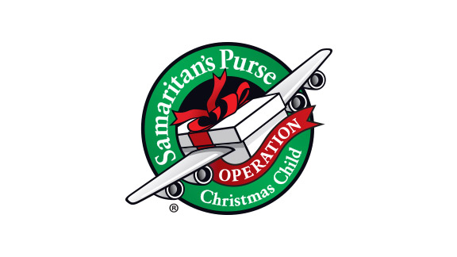
70 Ideas for Shoeboxes

- Prayer...mandatory!
- Pencils
- Pencil Sharpener
- Ink pens
- Crayons
- Colored pencils
- Erasers
- Scissors
- Glue sticks
- Notebooks
- Coloring books
- Drawing pads
- Loose leaf paper
- Small notebooks
- Sticker books
- Stickers
- Calculator
- Ruler
- Pencil case
- Backpack
- Washcloth
- Soap
- Deodorant
- Toothbrush
- Brush/comb
- Hair bows/clips/bands
- Dresses
- Shirts
- Shorts/pants
- Underwear
- Socks
- Pajamas
- Hats/caps
- Bandana/scarf
- Shoes/sandals/flip flops
- Sunglasses
- Jewelry/watch
- Small purse
- Flashlight & batteries
- Water bottle
- Reusable dishes/utensils
- Gardening kit
- Sewing kit
- Craft kit
- Tool kit
- Cooking kit
- Fishing kit
- Barbie doll
- Baby doll
- Trucks/cars
- Small action figures
- Legos
- Puzzles
- Yo-yo
- Marbles
- Jump ropes
- Soft frisbee
- Playing cards
- Baseball/glove
- Football
- Soccer ball
- Rubber bouncy ball
- Harmonica/flutes
- Story books
- Stuffed animals
- Blanket
- Band-aids
- Binoculars
- A personal note/picture
- Love…mandatory!

